Azura is a little girl. Recently she has completed a math course. To test how usefulness the course was, she is now trying to solve a problem. The problem is one of the home tasks she was given by his course teacher. The problem is given as a function like below:

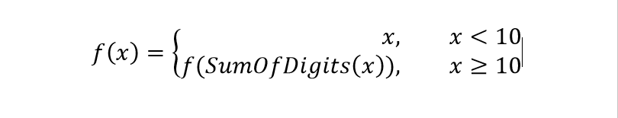

Where the $SumofDigits(x)$ function returns sum of the digits of the number x.

It’s an easy task, right? But the actual problem is a bit more complex for her.

The original problem is as follows.

You are given q queries of type $l, r, k$.

The answer to each query is how many times the number k appears in the sequence $f\left(l\right), f\left(l+1\right), f\left(l+2\right)……f(r)$.

Can you solve the problem ?